MODULE: 5 (JQuery Basic, Effects & Advance)

• What is JQuery?

Ans. jQuery is a small, light-weight and fast JavaScript library. It is cross-platform and supports different types of browsers. It is also referred as? write less do more? because it takes a lot of common tasks that requires many lines of JavaScript code to accomplish, and binds them into methods that can be called with a single line of code whenever needed. It is also very useful to simplify a lot of the complicated things from JavaScript, like AJAX calls and DOM manipulation.

* jQuery is a small, fast and lightweight JavaScript library.
* jQuery is platform-independent.
* jQuery means "write less do more".
* jQuery simplifies AJAX call and DOM manipulation.

• How to Apply CSS Using JQuery, How to Add Class and Remove Class in JQuery, JQuery Animation?

Ans. apply css using JQuery: the css() method sets or return one or more style properties for the selected elements.

to return the value of a specified css propery.

exa. css("propertyname");

$("p").css("background-color","blue");

Add class and remove class in jQuery:-

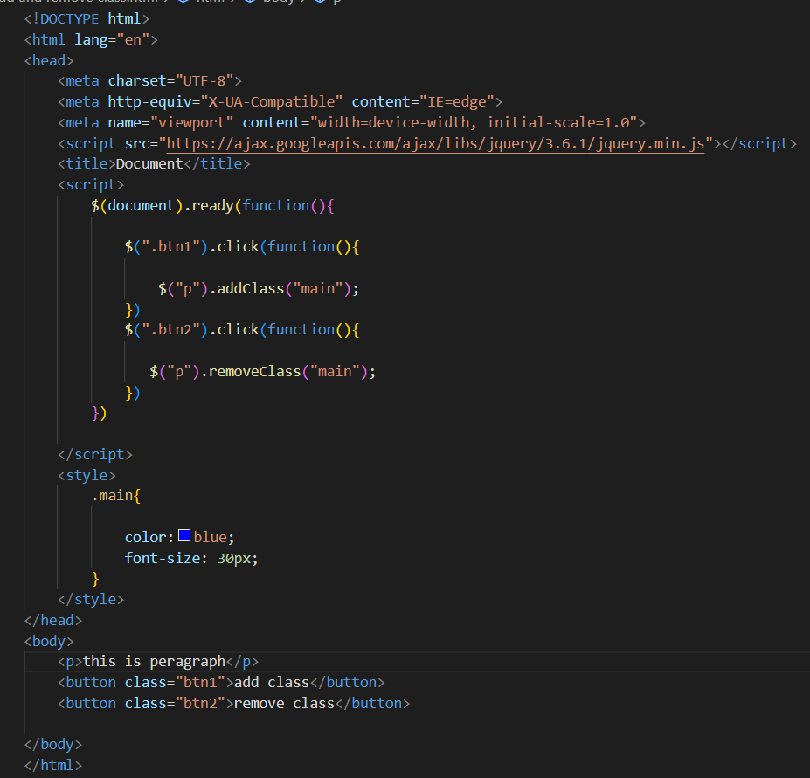

jQuery animation:-

\*hide and show –

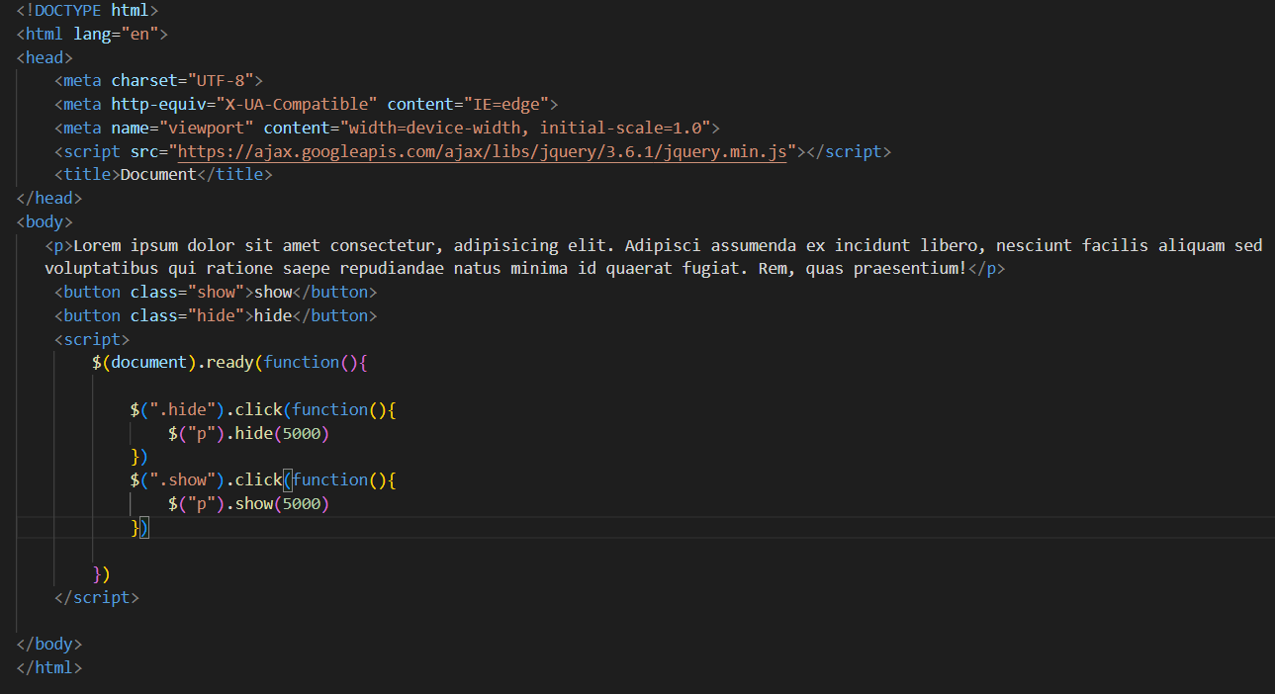

\*Fade in and Fade out :-

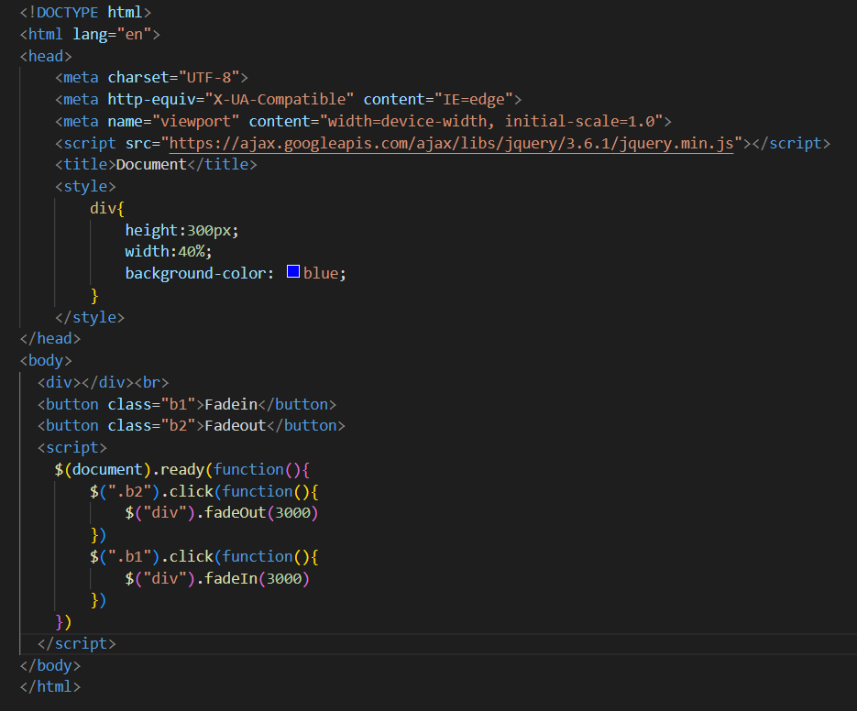

\*Toggle:-

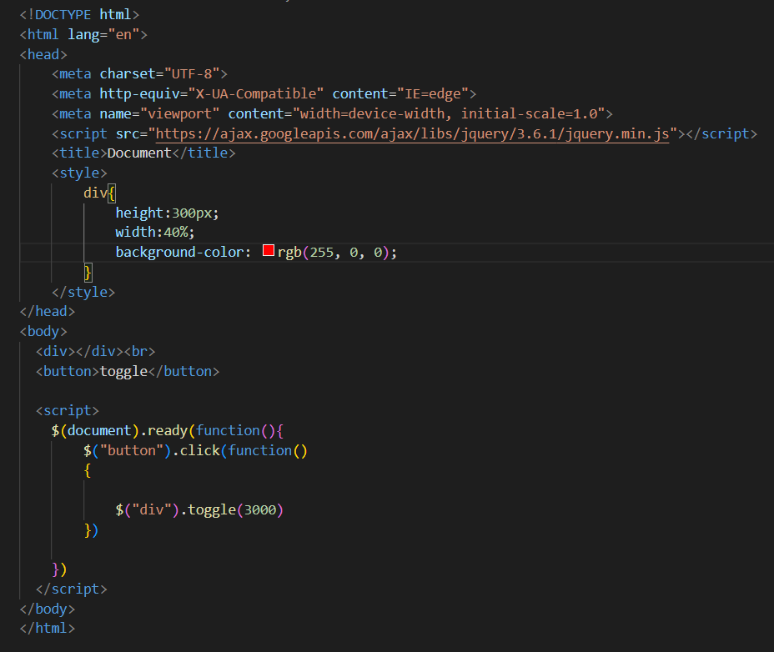

• How to create slider with animation?

Ans. you can make slider using three types

1.slidedown ()

2.slideup ()

3.slidetoggle ()

\*Slidedown and Slideup:-

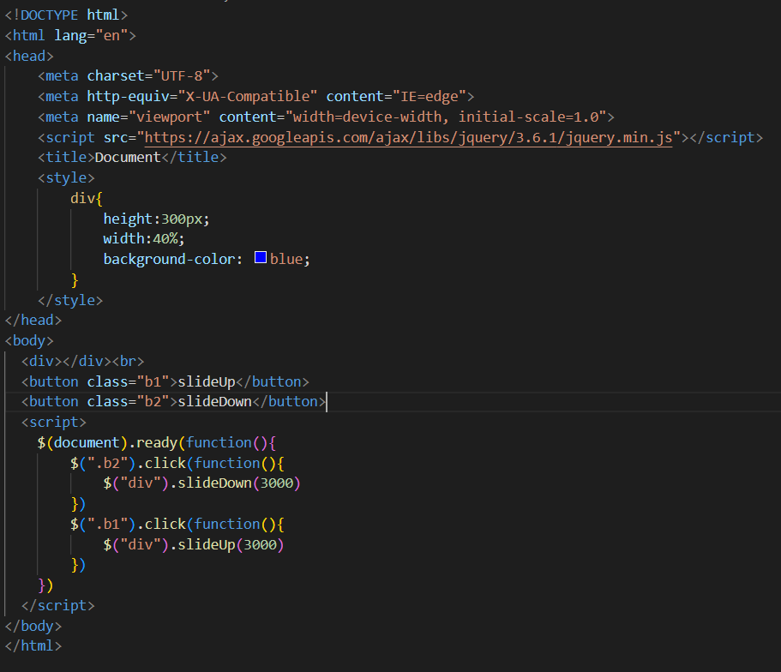

\*Slidetoggle:-

